**Database Systems Lab**

**BSCS F18 Afternoon**

**Lab 7B**

**Roll# BCSF18A036**

**Instructions:**

* You must complete all tasks individually. Absolutely **NO** collaboration is allowed.
* Any traces of plagiarism/cheating would result in an “F” grade in this course.
* Late submissions will **NOT** be accepted, in any case.

**Submission Procedure:**

* **Edit this file for solution.**
* You are required to submit PDF file.
* The file should contain the question, the query and the screen short of output after running the query.
* You have to submit your lab file on following email: [dbscs18aft@gmail.com](mailto:dbscs18aft@gmail.com) .
* The subject of the email should be **YourRollNumber_Lab_NumberCode**. e.g. BCSF18A123_Lab_7X.

**Task 1**

FIND THE UNION OF DEPARTMENT NUMBER 10 AND DEPARTMENT NUMBER 20.

Ans. select * from emp where deptno=10

UNION

select * from emp where deptno=20

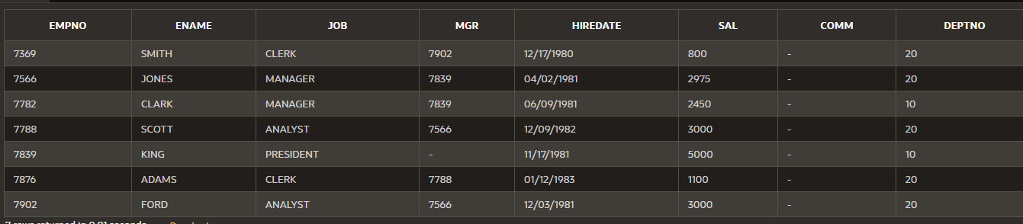

**Task 2**

FIND THE INTERSECT OF DEPARTMENT NUMBER 10 AND DEPARTMENT NUMBER 20.

Ans. select job from emp where deptno=10

Intersect

select job from emp where deptno=20

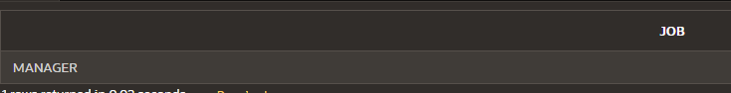

**Task 3**

FIND THE MINUS OF DEPARTMENT NUMBER 10 AND DEPARTMENT NUM8ER 20.

Ans. select job from emp where deptno=10

minus

select job from emp where deptno=20

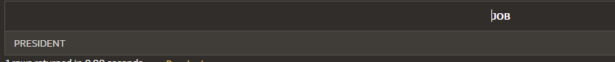

**Task 4**

FIND THE SALARIES OF THOSE EMPLOYEES WHO EARN MORE THEN CLARK'.

Ans.

select Sal from emp

where sal> (select sal from emp where ename Like 'CLARK')

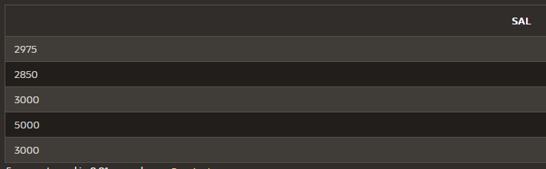

**Task 5**

FIND THE JOB WHICH HAS THE HIGHEST AVERAGE SALARY.

Ans. select job from emp

where sal=(select max(avg(sal)) from emp group by job)

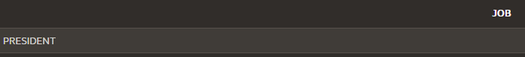

**Task 6**

LIST THOSE DEPARTMENT WHO DOSE NOT HAVE ANY EMPLOYEES.

Ans. select deptno from dept

where deptno not in (select deptno from emp)

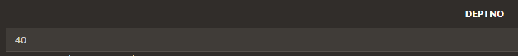

**Task 7**

FIND THE MAXIMUM SALARIES WITH EMPLOYEE NAME.

Ans. Select ename,sal from emp

where sal  =any  (select min(sal) from emp group by deptno)

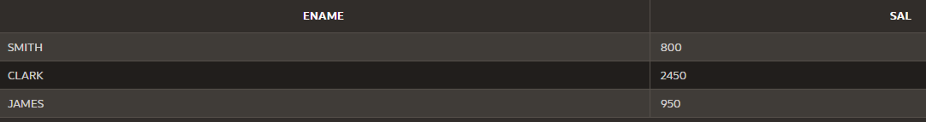

**Task 8**

FIND ALL EMPLOYEES WHO HAVE THE SAME JOB AS MARTIN.

Ans. select * from emp

where job Like (select job from emp where ename Like'MARTIN')

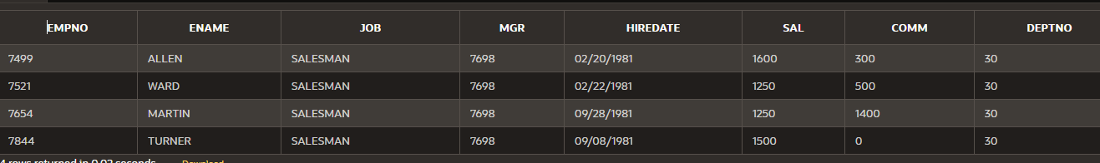

**Task 9**

FIND THE MINIMUM THREE SALARIES IN EACH DEPARTMENT.

Ans.

**Task 10**

FIND ALL EMPLOYEES WHO EARN MORE THAN THE AVERAGE SALARY OF EMPLOYEES IN THEIR OWN DEPARTMENT AND SORT BY DEPARTMENT NO.

**Task 11**

FIND ALL THE DEPARTMENTS, WHICH HAVE AN-AVERAGE SALARY IS GREATER THAN DEPARTMENT NUMBER 10.

**Task 12**

FIND ALL EMPLOYEES WHO EARN MORE THAN ANY EMPLOYEE IN DEPARTMENT 10.

Ans**.** select * from emp

where sal >any(select sal from emp where deptno=10) And deptno <>10

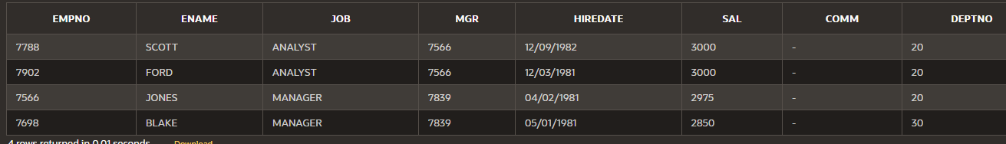

**Task 13**

FIND ALL EMPLOYEES IN DEPARTMENT NUMBER 10 WHOSE JOBS ARE THE SAME AS THE EMPLOYEES JOB IN THE SALES DEPARTMENT.

**Task 14**

DISPLAY THE NAMES AND HIRE DATES FOR ALL EMPLOYEES WHO WERE HIRED BEFORE THEIR MANAGERS, ALONG WITH THEIR MANAGER’S NAMES AND HIRE DATES. LABEL THE COLUMNS EMPLOYEE, EMP HIRED, MANAGER, AND MGR HIRED, RESPECTIVELY.

**Task 15**

FIND ALL JOBS WITH EITHER THE SAME OR AS 'CLARK' OR SALARY GREATER THAN OR EQUAL TO FORD, ORDER BY JOB AND SALARY

**Task 16**

FIND AVERAGE AND SUM OF THE SALARIES OF EACH JOB EXCLUDING THE JOB OF BLAKE.